Data Collection and Preprocessing Phase

Date | 30/06/2024
Team ID | LTVIP2025TMID47084
Project Title | Revolutionizing Liver care : Predicting Liver cirrhosis using Advanced machine learning Techniques
Maximum Marks | 6 Marks

Data Exploration and Preprocessing Template
The images will be preprocessed by resizing, normalizing, augmenting, denoising, adjusting contrast, detecting edges, converting color space, cropping, batch normalizing, and whitening data. These steps will enhance data quality, promote model generalization, and improve convergence during neural network training, ensuring robust and efficient performance across various computer vision tasks.

Section | Description
Data Overview | There are many popular open sources for collecting the data. Eg: kaggle.com, UCI repository, etc. In this project we have used .csv data
Data Preparation | These are the general steps of pre-processing the data before using it for machine learning
Handling missing values | We use Handling missing values For checking the null values
Handling categorical data | As we can see our dataset has categorical data we must convert the categorical data to integer encoding or binary encoding
Handling Outliers in Data | With the help of boxplot, outliers are visualized. And here we are going to find upper bound and lower bound of numerical features with some mathematical formula

Data Preprocessing Code Screenshots
Collect the dataset | Please refer to the link given below to download the dataset. link: liver cirrhosis prediction (kaggle.com)
Importing the libraries | 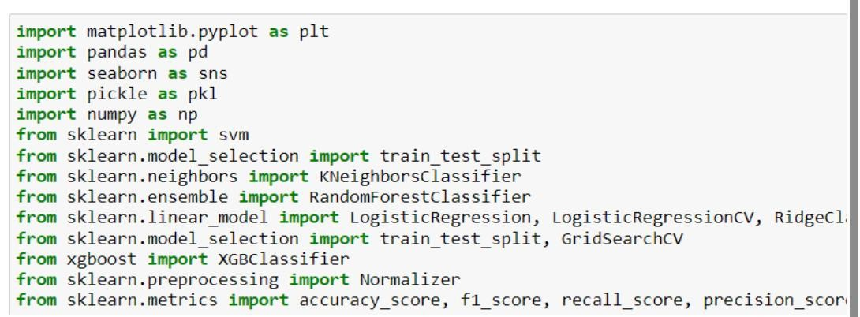
Loading Data | We use the code df=pd.read_csv("/content/HealthCare.csv")  For reading the dataset
Handling missing values | 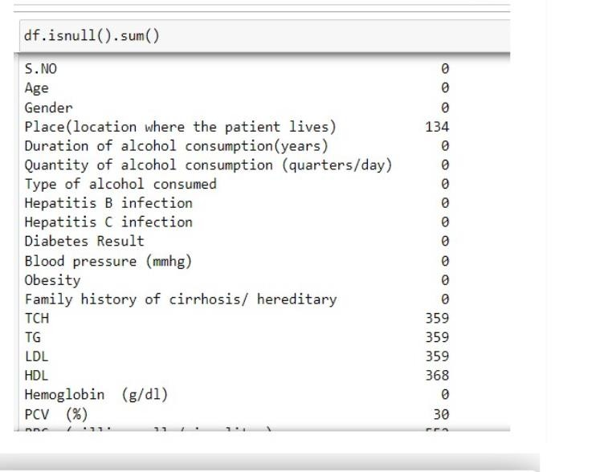
Handling Categorical values | 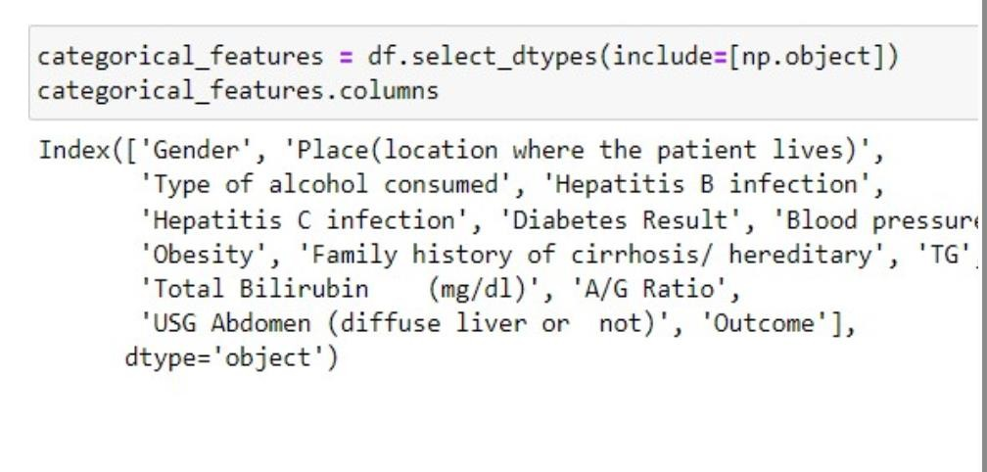
Handling Outliers | 